**Name:S.Prakul**

**192210073**

**EXP 12:Create a Virtual Machine with 1 CPU, 2GB RAM and 15GB storage disk using a Type 2 Virtualization Software.**

**Step1:create a workstation**

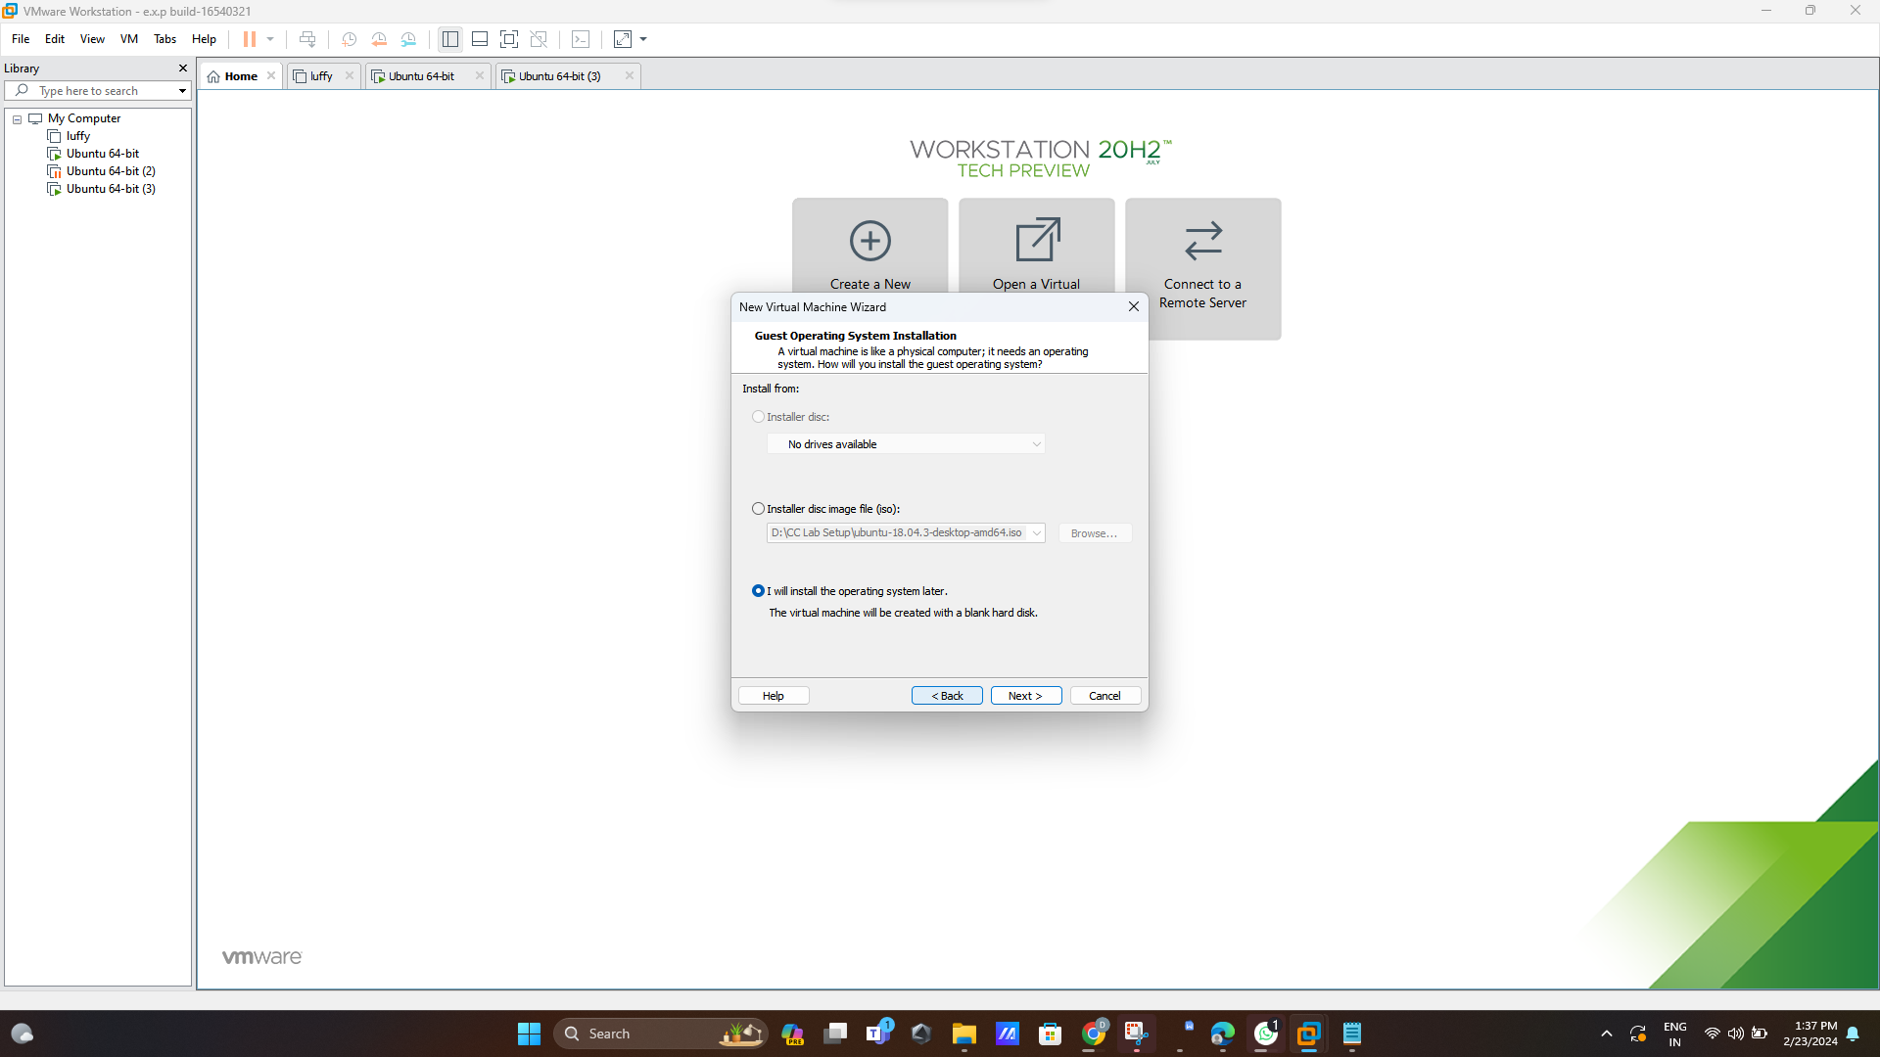

**Step 2:CREATE A FILE NAME UBUNTU ITSELF**

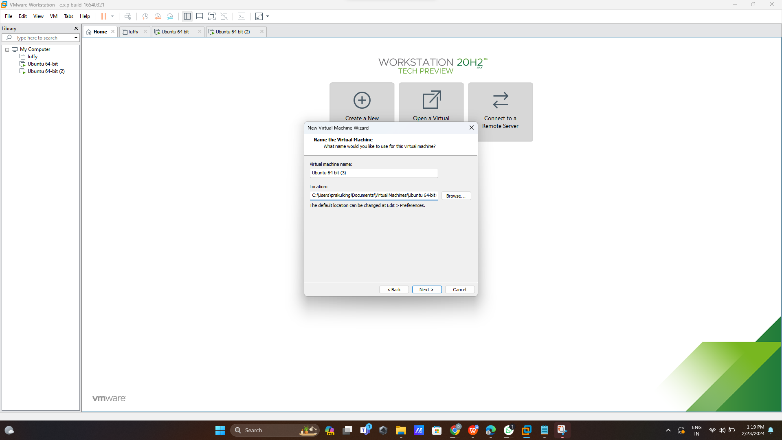

**Step 3: declare size as 15GB**

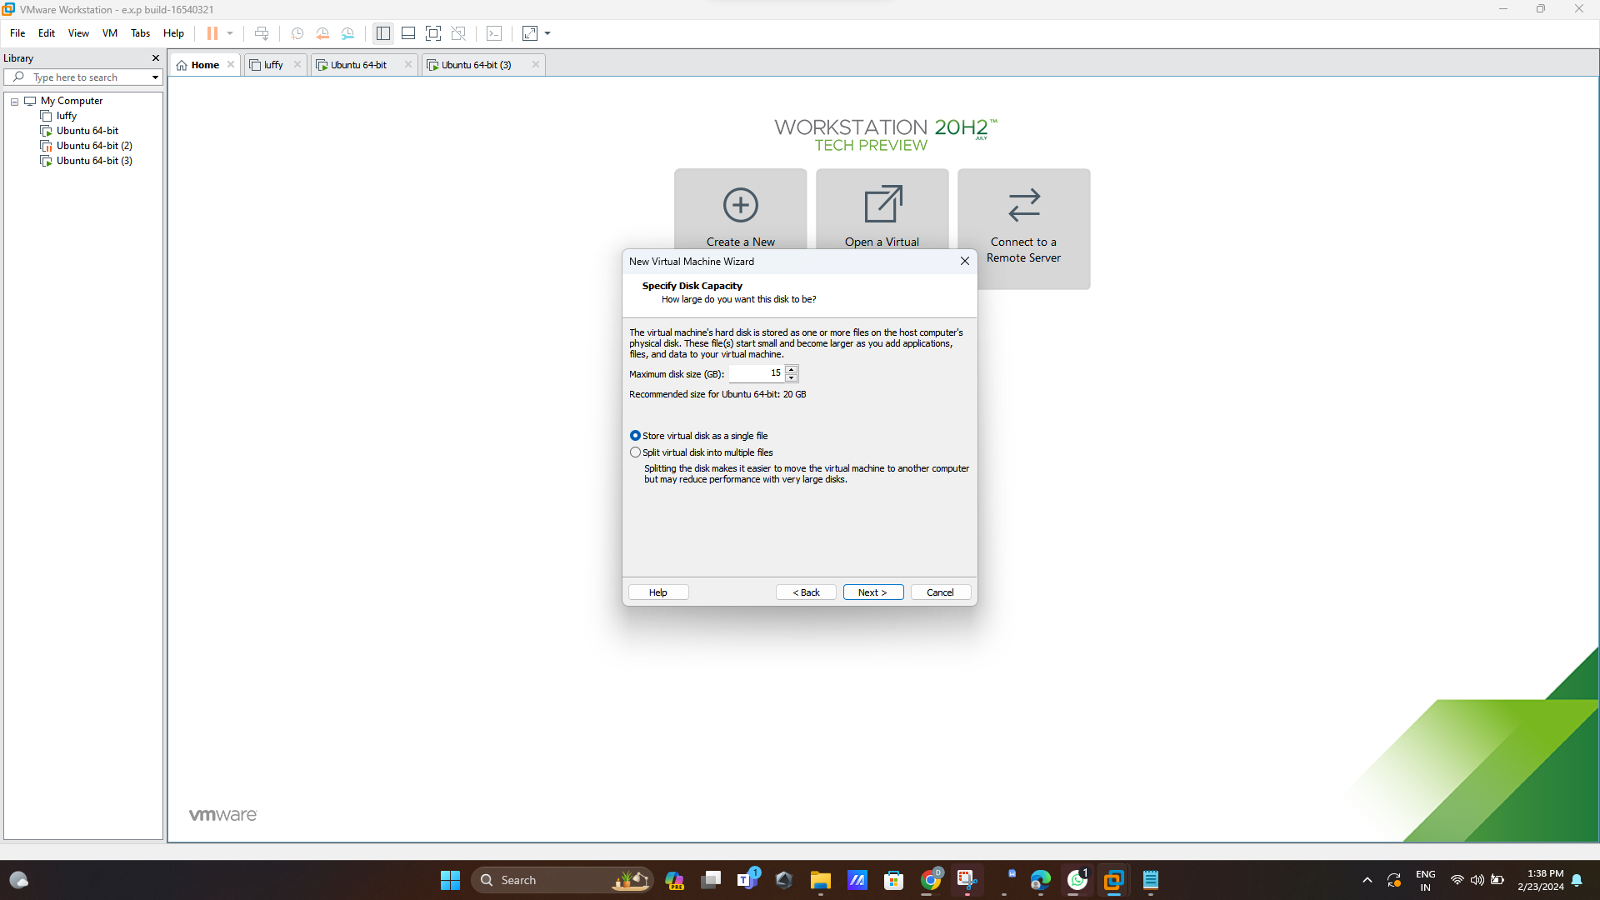

**Step 4: Then virtual machine will create as following setting we need to give next**

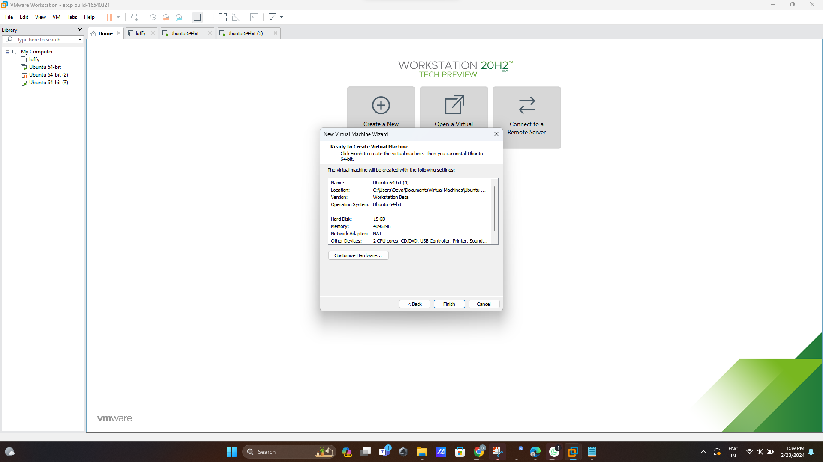

**Step 5: in the left side it will the system ubuntu setting here 15 gb is used in harddisk**

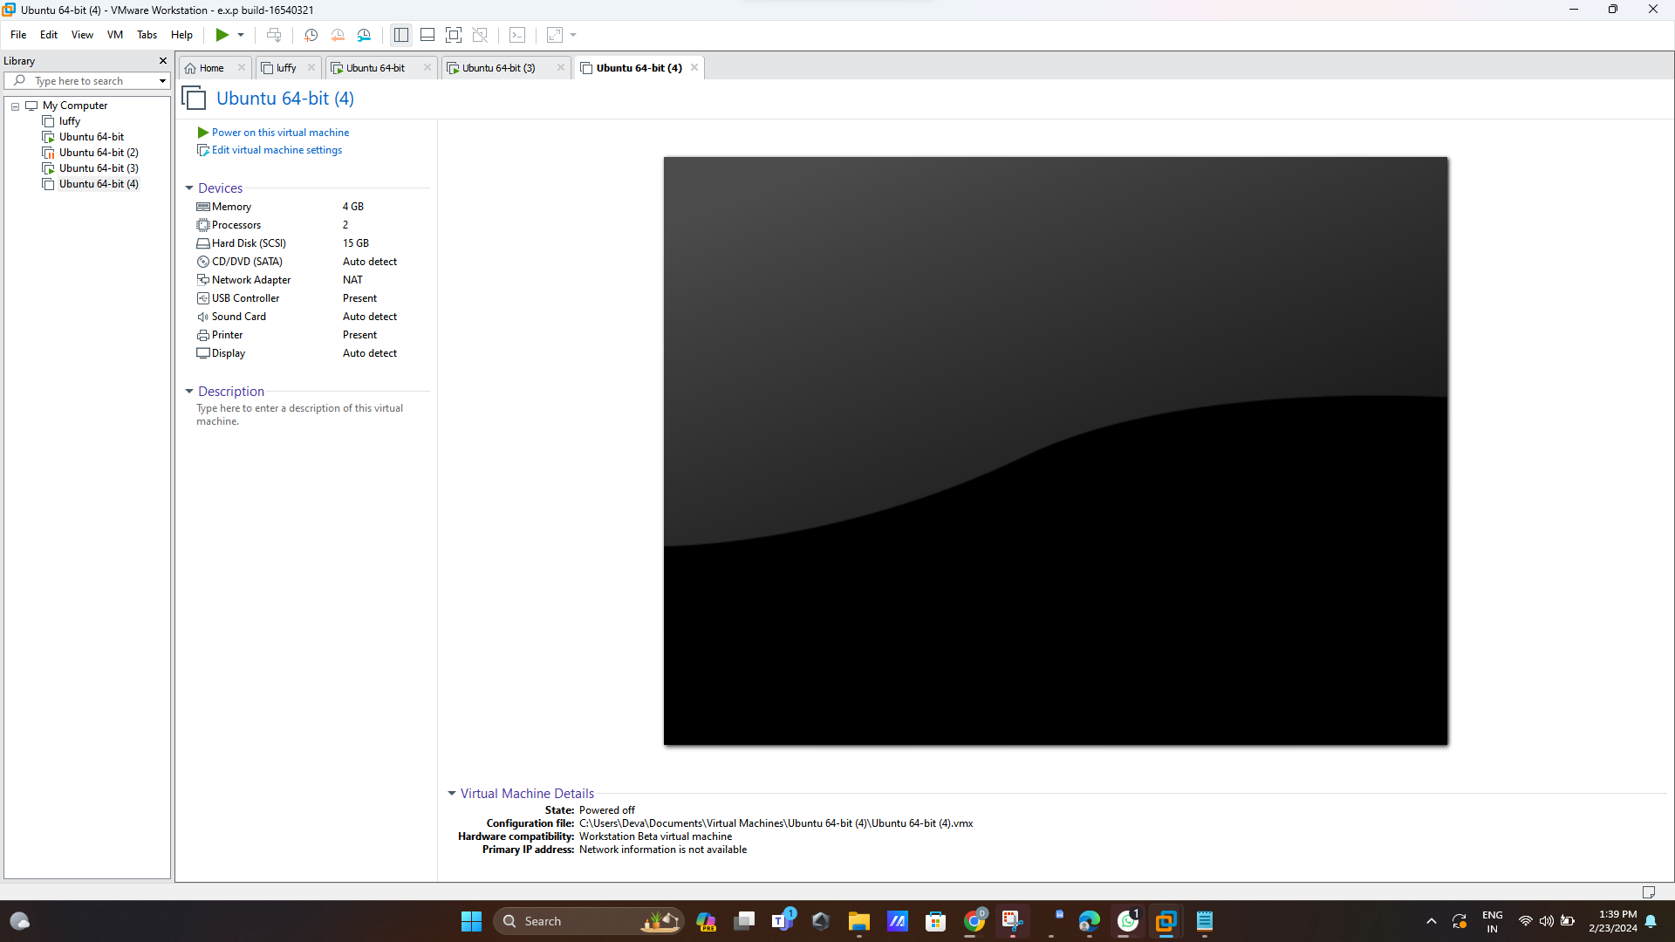

**Step 6:Click memory and change size 4gb into 2gb**

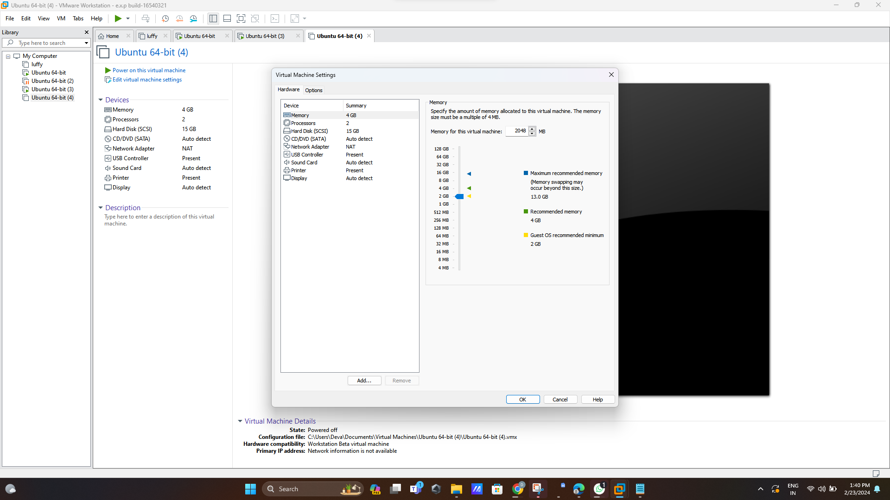

**Step 7:size has been changed into 2gb as you can see the below picture**

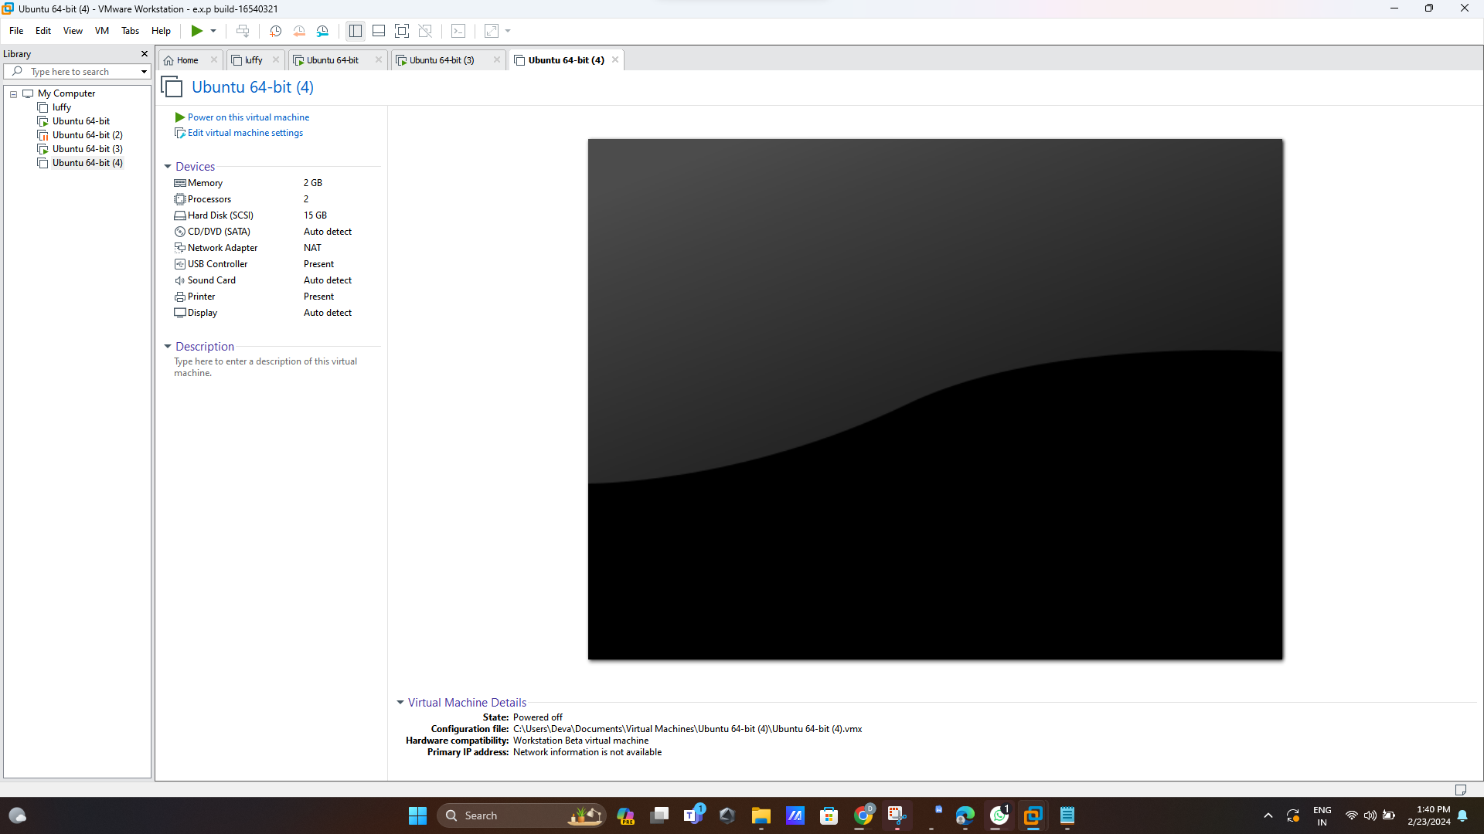

**Step 8:Now change processors size**

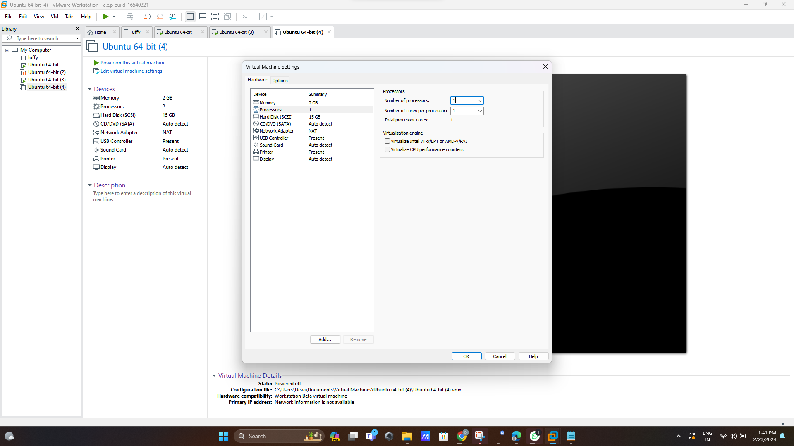

**Step 9: Therefore Final output is here**

